# CS 255 System Design Document Template

## UML Diagrams

### UML Use Case Diagram

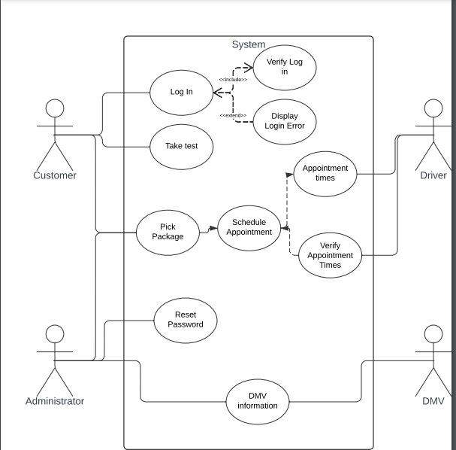

### UML Activity Diagrams

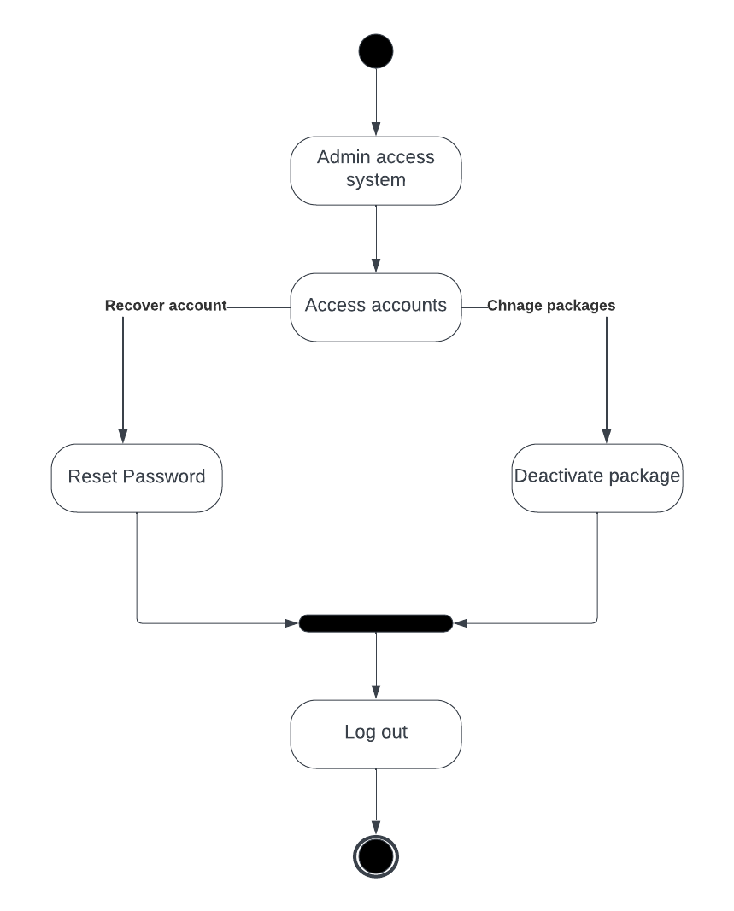

### UML Sequence Diagram

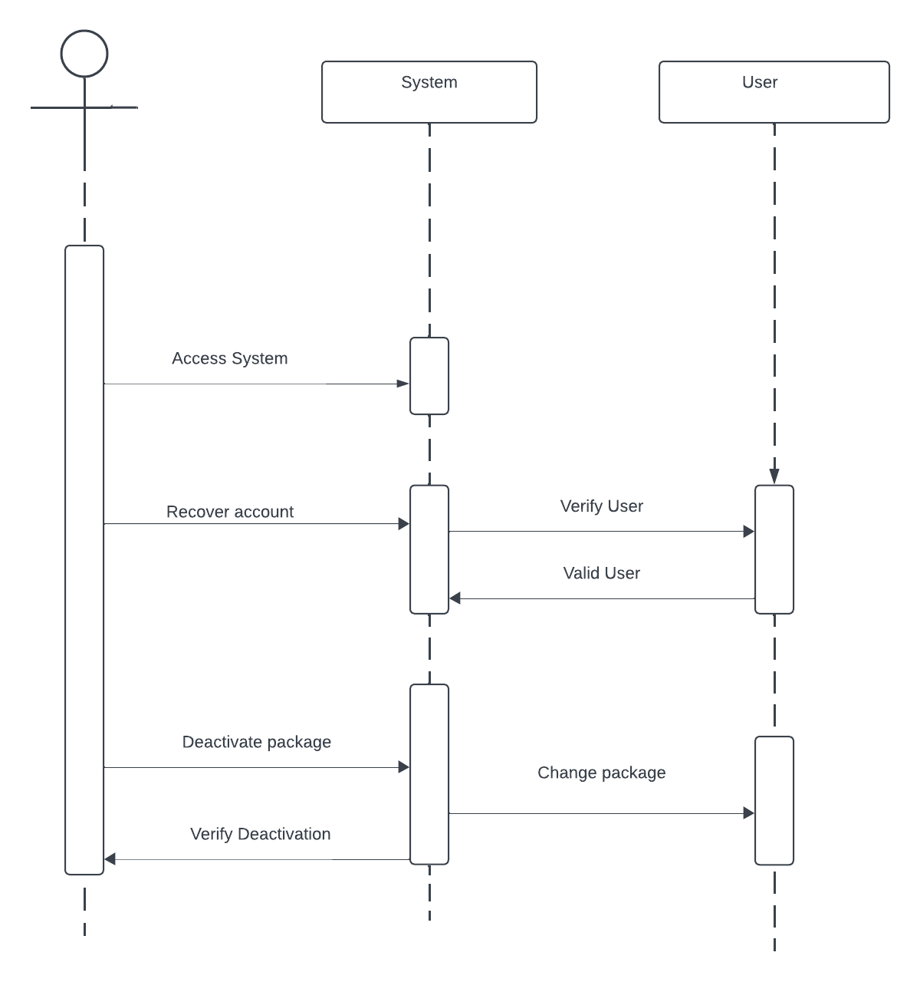

### UML Class Diagram

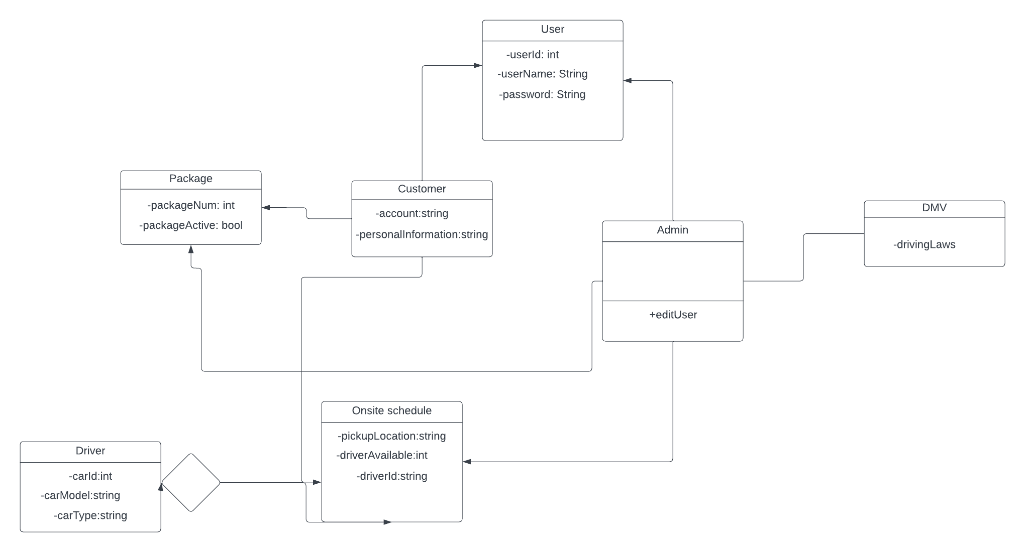

## Technical Requirements

Computer: A device such as a desktop, laptop, or tablet is required to access the website. This could be any computing device that allows you to interact with web content.

Internet Access: To use the website, a reliable internet connection is necessary. Internet access enables the computer to communicate with the website's server and retrieve the necessary information.

Web Browser: A web browser is essential for navigating and interacting with the content on the website. Popular web browsers include Chrome, Firefox, Safari, and Edge. The choice of browser may depend on personal preference or specific requirements.

Windows Operating System: The technical requirement specifies the use of the Windows operating system. This implies that the website is designed to be compatible with and accessible through devices running the Windows OS. It's worth noting that websites can be compatible with various operating systems, and specific requirements may vary.

In summary, to access and use this system, you need a computer, internet access, a web browser, and a Windows operating system. These components collectively provide the necessary infrastructure for interacting with the website.